Topic:Local Tectonic Hazards
Lesson Plan Earth Science

Introduction:

The unit plan is designed to for five, 63 minute class periods and addresses the Earth Science Core Curriculum standards for the State of Utah. Students at this school meet in a block schedule (A/B Days), therefore this unit will take approximately 2 weeks to complete. The demographics for students in this class are as follows:

Latino 40%
Asian 16%
Middle Eastern 15%
Pacific Islander 15%
Caucasian 10%
African American 2%
Native African 2%

Approximately 45% of these students are English Language Learners. Two students receive special education services and have an IEP. The standards for this lesson are as follows:

Standard 2
Students will understand Earth's internal structure and the dynamic nature of the tectonic plates that form its surface.

Objective 3
Demonstrate how the motion of tectonic plates affects Earth and living things.

e. Design, build, and test a model that investigates local geologic processes (e.g., mudslides, earthquakes, flooding, erosion) and the possible effects on human-engineered structures (e.g., dams, homes, bridges, roads).

General Technology Standards (Grades 9-12)

Standard 7
Routinely and efficiently use on-line information resources to meet needs for collaboration, research, publications, communications, and productivity.
Standard 8
Select and apply technology tools for research, information analysis, problem-solving, and decision-making in content learning.

General Content Objectives

SWBAT

- E. Design, build, and test a model that investigates local geologic processes (e.g., mudslides, earthquakes, flooding, erosion) and the possible effects on human-engineered structures (e.g., dams, homes, bridges, roads).

Essential Question: What are the primary and secondary tectonic hazards? (Volcanoes, Earthquakes, Tsunamis, and Landslides) What tectonic hazards exist here in Utah?

General Language Objectives

SWBAT
- utilize new vocabulary and apply it to real world applications.
- search and retrieve information from maps and visuals and cite their findings verbally to peers and in written form in their science notebooks.
PART 1 : MOTIVATION
Technology Used:
For this portion of the lesson plan a visual image is projected onto the screen and used to elicit student responses and class participation. Following this exercise, direct instruction is given using a Power Point Presentation that has text and visuals embedded within.
Rationale:
The purpose behind the use of the image is that it replicates the environment in which students use their observations to create inferences. They are able to verbally cite their evidence for the claims that they make to the class. I have also found highly visual Power Point Presentations to be effective for my ESL students as the images give them a context for the vocabulary that is needed for the lesson.
- PICTURE DESCRIPTION
Students are shown an image and asked to make observations regarding it. They are to make verbal inferences based on their observations. Once multiple students have had a chance to participate the teacher reveals the details regarding the image. Hawaii Tsunami 1946 (Hilo Bay) Students are shown the learning objectives for the class period and asked to write the essential question in their science notebooks.
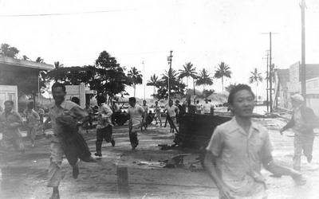
- Using DIRECT INSTRUCTION with PPT review primary and secondary tectonic hazards.
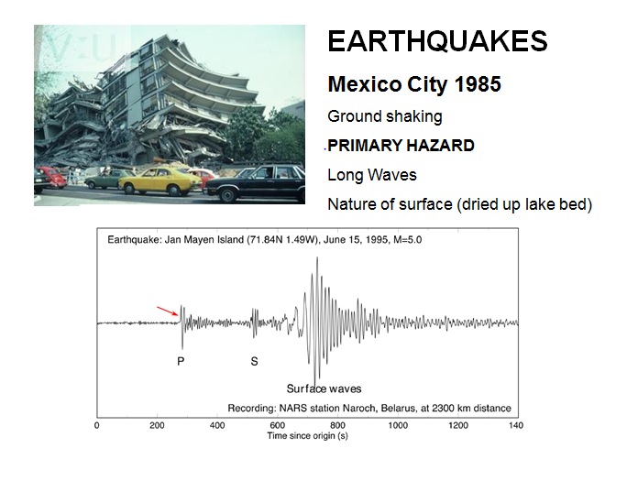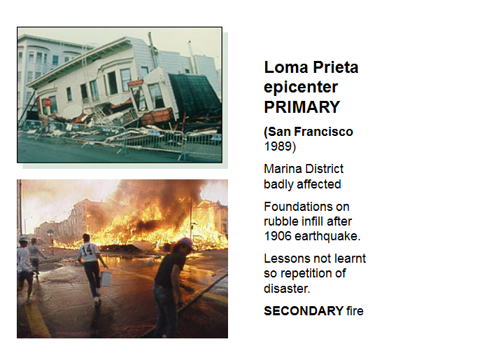
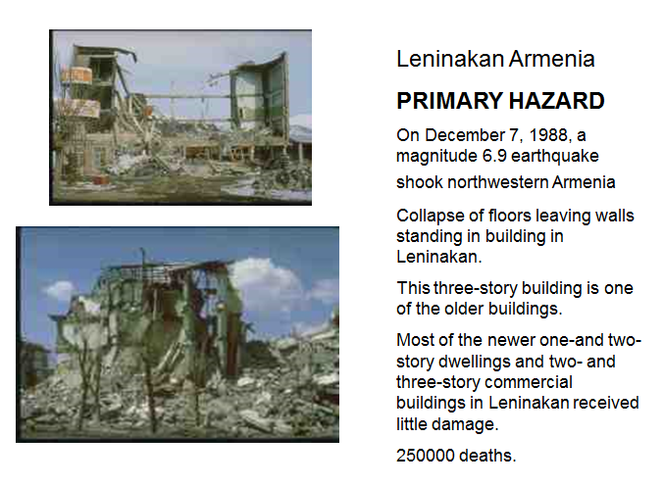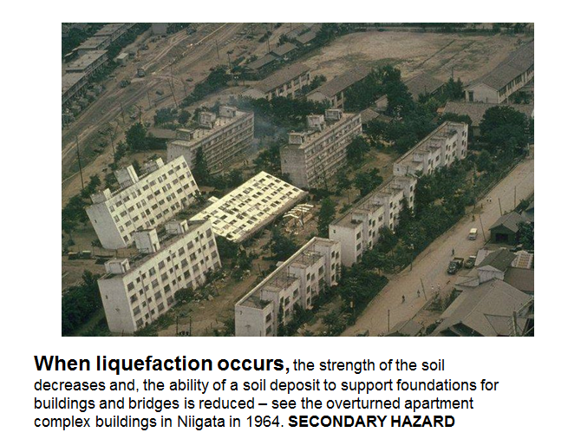

- THINK-PAIR-SHARE activity with elbow partners discussing the most common tectonic hazards in Utah.

TEACHING BASIC CONCEPTS:
Materials used for teaching: For this portion of the lesson we will use manipulatives as well as technology in order to engage student learning. We will access the University of Utah’s website that is linked to various seismic stations in order to see “real time” earthquakes happening across the state. We will access a video of the Christchurch earthquake and see some realistic hazards as they occur that are also common to Utah. Students will then build models using manipulatives to further understand the shaking hazards that exist for the different structures here in Utah. Students will also use an approved list of websites in order to complete a Treasure Hunt in small groups.
Rationale: Using a combination of the websites and the manipulatives gives students an opportunity to connect the experiments done in class with the real world applications of events on Earth.
- DEMONSTRATION of P and S waves using a “slinky”. Real time local P and S waves are shown to the class using the following link: http://www.seis.utah.edu/helicorder/utah_webi.htm

- VIDEO and DISCUSSION

Many of the homes in SLC are made of unreinforced masonry/brick. Show students the Christchurch earthquake video. Instruct them to follow the man dressed in black in the background of the scene. Also, direct their attention to the cracks that appear almost instantaneously in the sidewalk in the foreground. Remind students to STAY INSIDE in the event of an earthquake until the shaking has stopped. https://www.youtube.com/watch?v=duoS7hwJlrU

- MODEL

High and low frequency waves are modeled using marshmallows and uncooked spaghetti by students and the effects on large and small buildings is recorded in their science notebooks.

APPLYING KNOWLEDGE:

- DIRECT INSTRUCTION WITH PPT regarding Earthquake Hazards: Earthquake
Hazards:
Building/structure collapse
Rupture
Landslides
Fires
Liquefaction
Tsunami- luckily not a possibility in UTAH :)
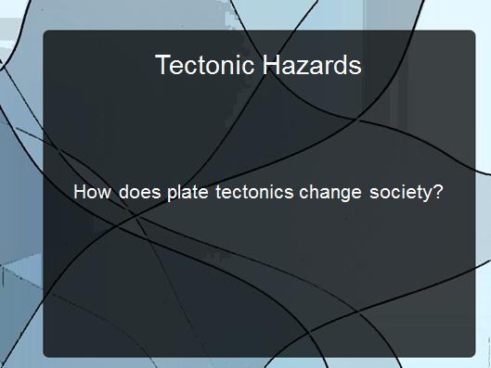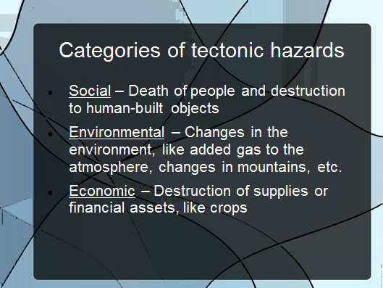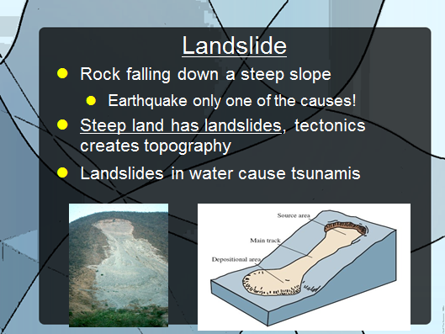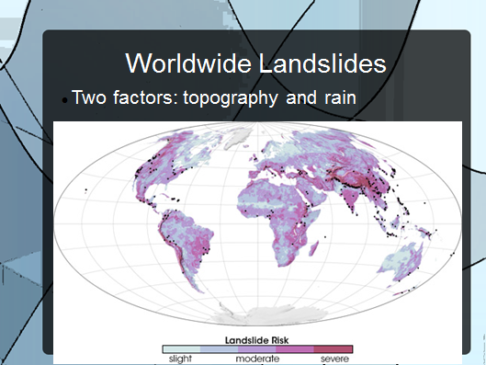
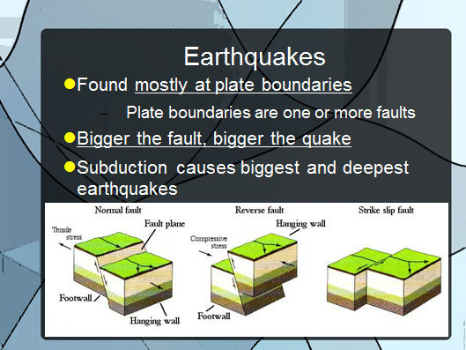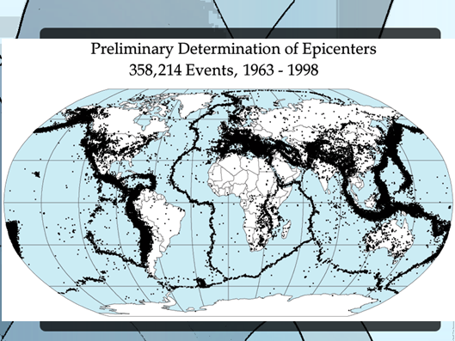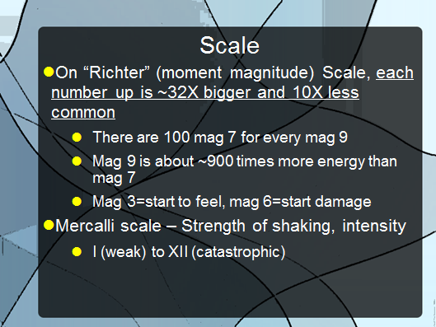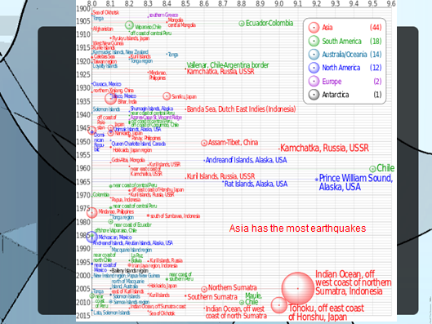
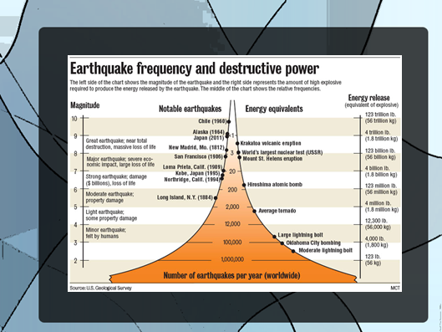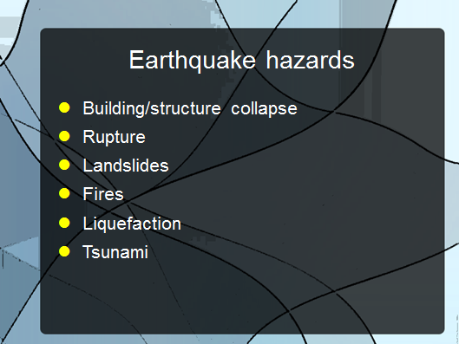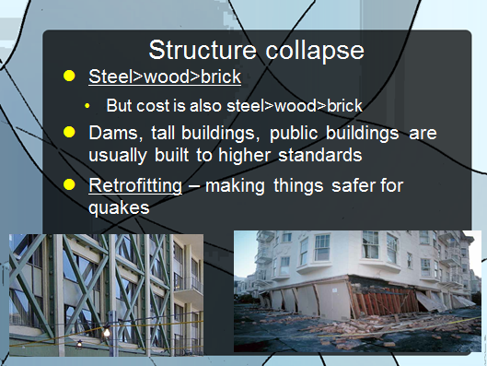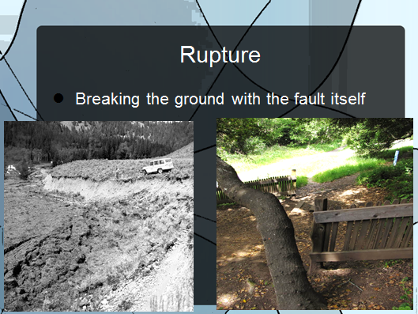
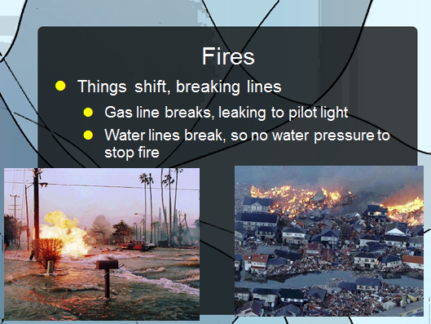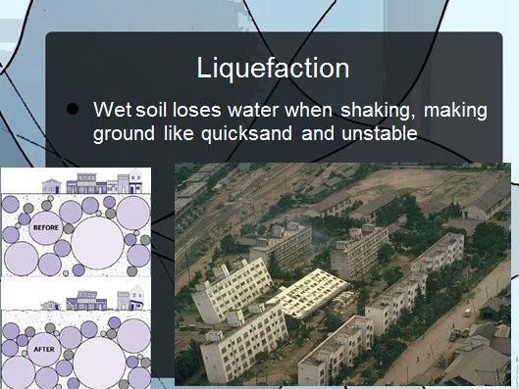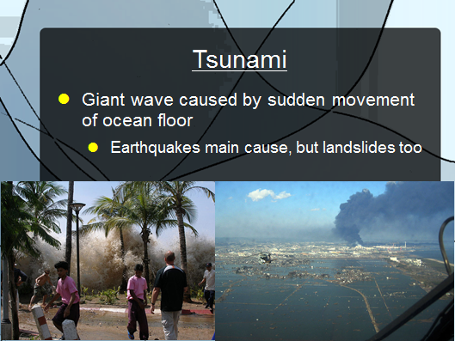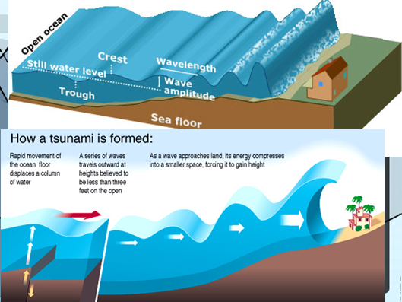
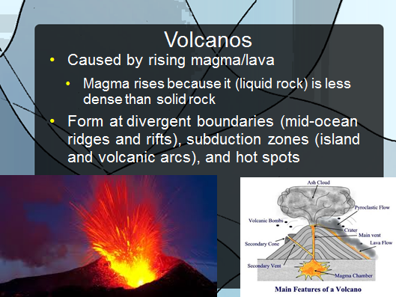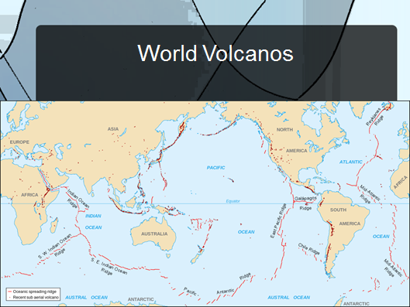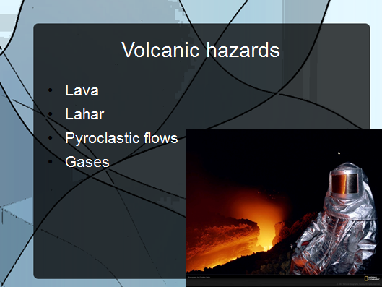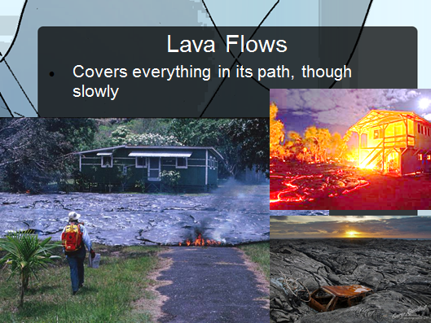
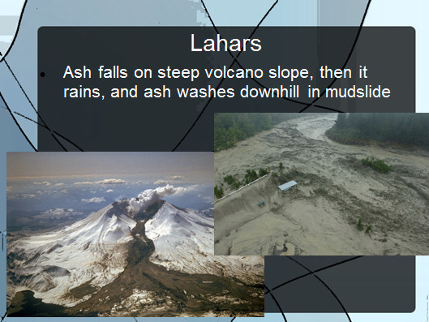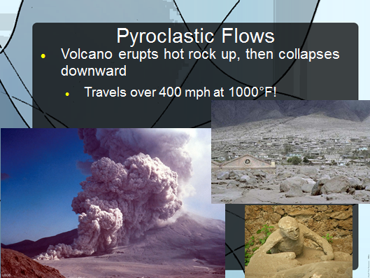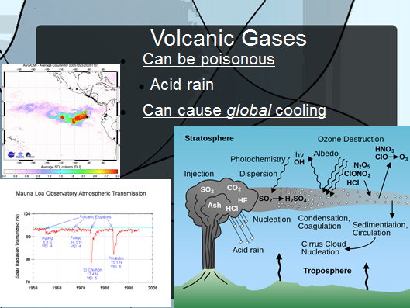
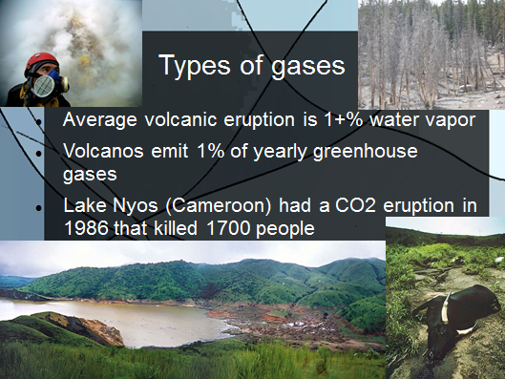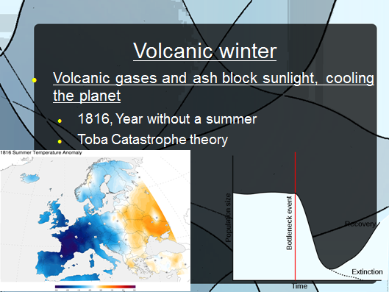

- DEMONSTRATION
The teacher begins the liquefaction demonstration. Students will discover how and why liquefaction would occur and relate to how that would affect citizens in Utah. Students are instructed to record their observations and conclusions in their science notebook.

- TREASURE HUNT
As a class four discussion questions will be used to initiate analyzing and critical thinking. Students will use an approved list of websites in order to obtain the answers. For each correct answer, the teacher will give them a letter to a fill in the blank question listed on the board.
Approved list of websites:
http://www.ce.washington.edu/~liquefaction/html/what/what1.html
http://www.resorgs.org.nz/images/stories/pdfs/Organisationsfacingcrisis/rural-organizational-impacts-mitigation.pdf
http://geology.utah.gov/hazards/earthquakes-faults/liquefaction/
The questions are as follows:
- What conditions need to be present in order for liquefaction to occur? U & T
- How can this affect cities, farms, wildlife, rivers, or others? A & E
- Does the Salt Lake Valley have conditions relating to liquefaction? R & T
- What can governments do to protect against damage from liquefaction. S & A

S A T U R A T E
______ _______ ________ ________ _______ _______ _______ _______

Once all groups are finished, students are asked how the Treasure Hunt word relates to liquefaction and to Utah tectonic hazards.

- GUEST SPEAKER

A community support liaison, from the Utah Department of Public Safety will come in at this point in the lesson plan and speak with the students about the hazards of earthquakes along the Wasatch Front, and how to prepare for such an emergency. The guest speaker will cover how different parts of the valley may be affected differently, specifically their community and the home structures that are prevalent. The speaker will discuss what community resources and national resources (e.g. FEMA) are available to them and how they get access to these resources. Time allotted for the guest speaker is 30-40 minutes, with a question and answers portion factored in. During this portion students will be taking notes in their science journals in their K-W-L charts on what they have learned about earthquakes hazards.

LESSON CLOSURE:
Materials Used for Teaching: In order wrap up the lesson students will use a mix of different types of media. Students will work in collaborative groups with current maps of the Salt Lake Valley in order to identify the specific hazards that exist at locations with which they are familiar. Students will also watch a video that made by the State of Utah made to educate the public in the event of an earthquake. Lastly, students will use their cell phones to report on the hazards that they find in their homes.
Rationale: Using the up-to-date maps students can relate the information they find directly to their personal lives. Seeing places that are familiar and gaining knowledge about them is empowering in the event of an earthquake. The video serves as a good overview of many of the points that were covered over the last two weeks. Students will complete the lesson by using their cell phones to text or email images to the teacher in order to highlight any earthquake hazards they find in their home. This will engage the students and their parents with the project as well as give them the tools to mitigate these hazards.
- COLLABORATIVE WORK + LAB

Students will work in small groups and complete the Salt Lake Shake/ Liquefaction Lab. Using two different UGS maps students will locate significant places in the valley and report the shaking potential, liquefaction potential and potential outcomes in the event of an earthquake in the Salt Lake Valley.

- VIDEO
Students will watch THE GREAT SHAKE OUT, a 5 min video that depicts a realistic outcome of a plausible earthquake along the Wasatch Front. Potential ways to mitigate the hazard is discussed.
https://www.youtube.com/watch?v=8Z5ckzem7uA
- SCAVENGER HUNT

Due the next class period students will evaluate the possible hazards that exist in their homes in the event of an earthquake. Students will be given a handout (see appendix) and be asked to complete steps 1-2 in their own home. The will draw from information learned about earthquake hazards from the guest speaker. Students will be asked to take pictures of hazards they find with their cell phone cameras, and email or text them to the teacher. Students are encouraged to share these possible hazards with their parents and neighbors and to educate and hopefully negate these potential dangers in their homes and community.

